Community Council Meeting
Minutes – 2.10.2023

- In Attendance: Jordan Yospe, Jessi Follett, Jessica Sims, Jessica Kelemen, Brian Nash, Shauna Smith, Wendy Fuja, Jessica Sims, Parker Huber

- Approved previous meetings minutes

- Steering Committee Update – French Immersion

  - Jessica/Wendy from Council, and English/French teacher from each school (Foxboro/Odyssey), as well as several district representatives
  - Met last Friday to discuss timeline as a Steering Committee, discussed an expedited timeline potentially and district needs to look at if they are going to speed up the timeline due to losing 4 French teachers next year (visas expiring, one that can’t afford college tuition for kids, and one that is leaving for personal reasons)
  - French teachers for both schools are already wondering what attrition will look like with losing 4 teachers
  - Looking at benefits of combining them, effects on diversity, how it would affect transportation and how that would be funded, etc.
  - They are doing a legitimate study and there is no decision that has been made yet
  - Putting together a survey to go to all parents in the two schools to understand the factors – focused on thoughts on the location of the program, if it moved would you continue to keep your kids in immersion, what are the benefits/drawbacks of immersion (going to all parents)
  - Challenges of immersion school this size
    - Challenges are the class sizes (funded at 26.85 students per teacher by legislature) – ends up causing splits, abnormal rotations, etc.
    - Students end up with same group of kids through 6th grade, sometimes causing challenges with finding the best learning environment for the student
    - District has spent $5-7M in “overstaffing” the two schools to accommodate the two programs
  - Some concerns about overpopulation of school if they move French exclusively to Odyssey
    - Staffing per student won’t change, always remains the same
    - Odyssey built for 800-900 students, but growth hasn’t happened yet (have space in the building right now, using some space for speech, etc.)
    - Part of the survey/study is to understand the inflow/outflow of students to each school; For example, understanding how many of Foxboro French students would come over (essentially everything is on the table right now)
    - Originally discussed moving it all to Foxboro, then back to Odyssey, but are trying to slow down and understand what the parents want
    - If all Foxboro French students came to Odyssey, Foxboro would then be 40% reduced lunch which would make them a title 1 school
    - There are 16 students in 1st grade classes, which puts burden on other classes (number should be 22 or so)
  - No discussion of not offering French at all at either school
  - Some concerns about how bringing Foxboro population to Odyssey will affect any behavioral issues, etc.
  - Steering committee will make a recommendation, but ultimately the superintendent will make the final decision
  - Will know in next week or two if superintendent will approve speeding up the study or not (which would affect budgets, etc.) – Would need to have a decision by April 1 to make any changes (which would cause trickledown of budgeting, etc. for next year)
  - Discussion on estimated FTE and proposed class sizes and effect of combining programs; Also discussed competency-based approaches to avoid class splits (below illustration); Lower grades is much harder to do splits with
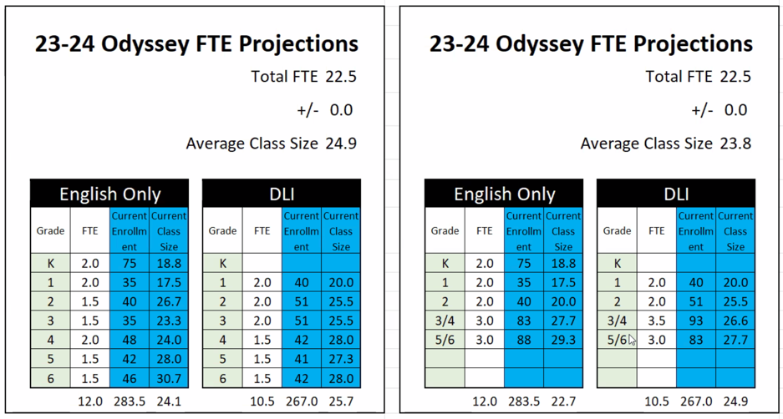
  - Next Steps
    - Principal Nash and others on Steering Committee to keep Community Council updated on current state

Fundraiser Discussion
- Losing some funding next year, and technology is going up in price. Below is the goal for the fundraiser as a community council and below are what those funds would go to:
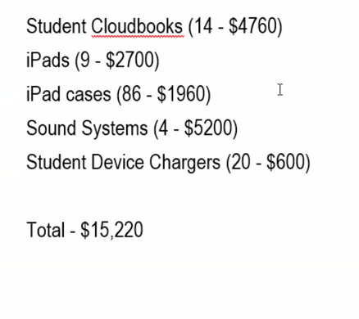
- All devices are on a 5 year rotation
- Next Steps
  - Ensure fundraising is an agenda item for the next meeting to brainstorm ideas

